SUKHPREET JENA
SUPERSET ID:- 6399056
Hello World RESTful Web Service
application.properties

spring.application.name=spring-learn

logging.level.org.springframework=info
logging.level.com.cognizant.springlearn=debug
logging.pattern.console=%d{yyMMdd}|%d{HH:mm:ss.SSS}|%-20.20thread|%5p|%-25.25logger{25}|%25M|%m%n

server.port=8083

HelloController.java

package com.cognizant.springlearn.controller;

import org.slf4j.Logger;
import org.slf4j.LoggerFactory;
import org.springframework.web.bind.annotation.GetMapping;
import org.springframework.web.bind.annotation.RestController;

@RestController
public class HelloController {

private static final Logger LOGGER = LoggerFactory.getLogger(HelloController.class);

@GetMapping("/hello")
public String sayHello() {
LOGGER.info("START");
String message = "Hello World!!";
LOGGER.info("END");
return message;
}
}

Output:

Chrome Browser:

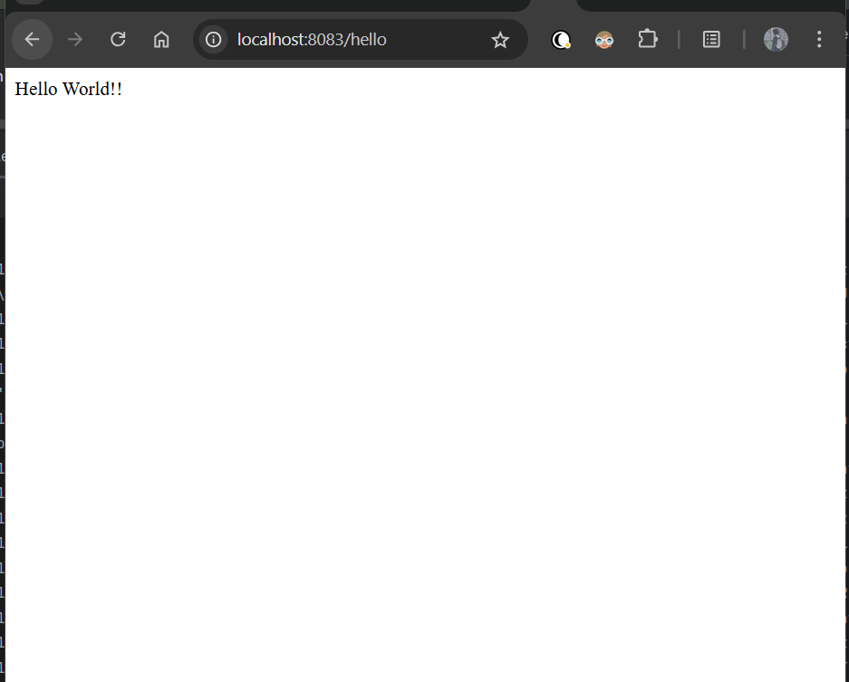

Postman:
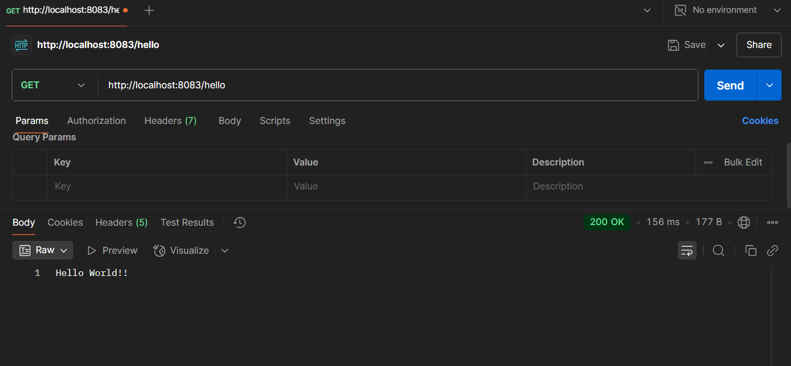

REST - Country Web Service
CountryController.java

package com.cognizant.springlearn.controller;

import com.cognizant.springlearn.Country;
import org.slf4j.Logger;
import org.slf4j.LoggerFactory;
import org.springframework.context.ApplicationContext;
import org.springframework.context.support.ClassPathXmlApplicationContext;
import org.springframework.web.bind.annotation.RequestMapping;
import org.springframework.web.bind.annotation.RestController;

@RestController
public class CountryController {

private static final Logger LOGGER = LoggerFactory.getLogger(CountryController.class);

@RequestMapping("/country")
public Country getCountryIndia() {
LOGGER.info("START getIndia");
ApplicationContext context = new ClassPathXmlApplicationContext("country.xml");
Country country = context.getBean("in", Country.class);
LOGGER.info("END getIndia");
return country;
}
}

country.xml

<?xml version="1.0" encoding="UTF-8"?>
<beans xmlns="http://www.springframework.org/schema/beans"
xmlns:xsi="http://www.w3.org/2001/XMLSchema-instance"
xsi:schemaLocation="http://www.springframework.org/schema/beans
https://www.springframework.org/schema/beans/spring-beans.xsd">

<bean id="country" class="com.cognizant.springlearn.Country" scope="prototype">
<property name="code" value="IN" />
<property name="name" value="India" />
</bean>

<bean id="in" class="com.cognizant.springlearn.Country">
<property name="code" value="IN" />
<property name="name" value="India" />
</bean>

<bean id="us" class="com.cognizant.springlearn.Country">
<property name="code" value="US" />
<property name="name" value="United States" />
</bean>

<bean id="de" class="com.cognizant.springlearn.Country">
<property name="code" value="DE" />
<property name="name" value="Germany" />
</bean>

<bean id="jp" class="com.cognizant.springlearn.Country">
<property name="code" value="JP" />
<property name="name" value="Japan" />
</bean>

<bean id="countryList" class="java.util.ArrayList">
<constructor-arg>
<list>
<ref bean="in"></ref>
<ref bean="us"></ref>
<ref bean="de"></ref>
<ref bean="jp"></ref>
</list>
</constructor-arg>
</bean>

</beans>

Output:

Chrome Browser
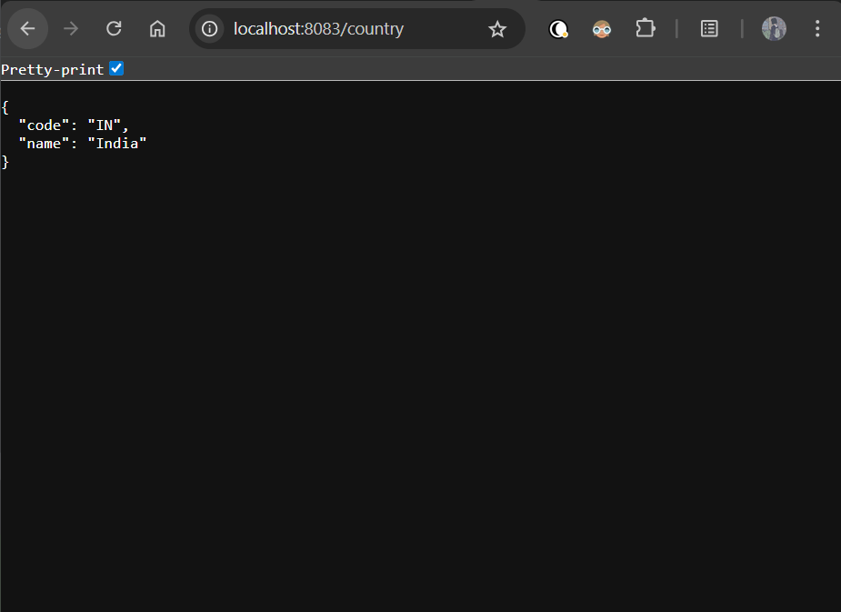

Postman
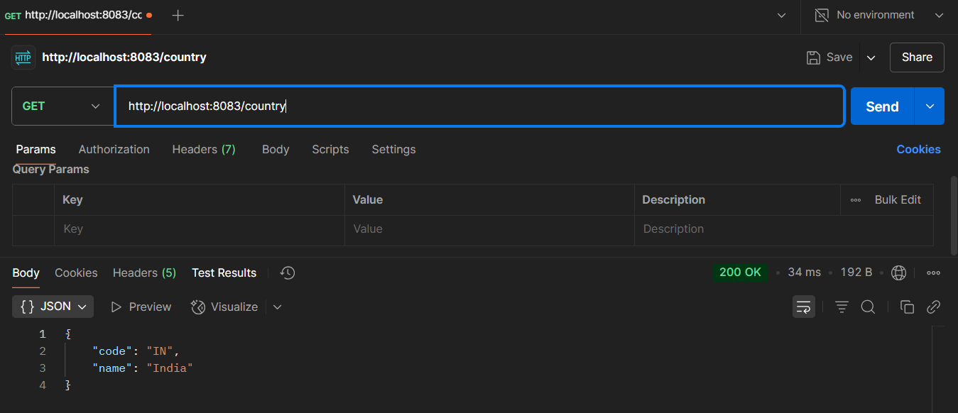
Terminal:
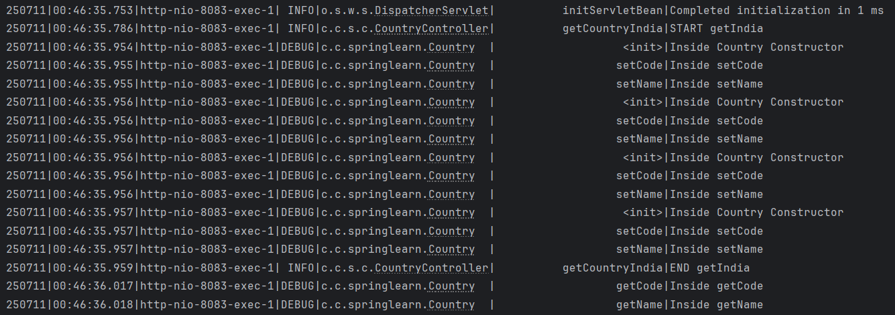

REST - Get all countries

CountryController.java

package com.cognizant.springlearn.controller;

import com.cognizant.springlearn.Country;
import org.slf4j.Logger;
import org.slf4j.LoggerFactory;
import org.springframework.context.ApplicationContext;
import org.springframework.context.support.ClassPathXmlApplicationContext;
import org.springframework.web.bind.annotation.GetMapping;
import org.springframework.web.bind.annotation.RequestMapping;
import org.springframework.web.bind.annotation.RestController;

import java.util.List;

@RestController
public class CountryController {

private static final Logger LOGGER = LoggerFactory.getLogger(CountryController.class);

@RequestMapping("/country")
public Country getCountryIndia() {
LOGGER.info("START getIndia");
ApplicationContext context = new ClassPathXmlApplicationContext("country.xml");
Country country = context.getBean("in", Country.class);
LOGGER.info("END getIndia");
return country;
}

@GetMapping("/countries")
public List<Country> getAllCountries() {
LOGGER.info("START getAllCountries");
ApplicationContext context = new ClassPathXmlApplicationContext("country.xml");
List<Country> countryList = context.getBean("countryList", List.class);
LOGGER.debug("Countries: {}", countryList);
LOGGER.info("END getAllCountries");
return countryList;
}
}

Output:

Chrome Browser:
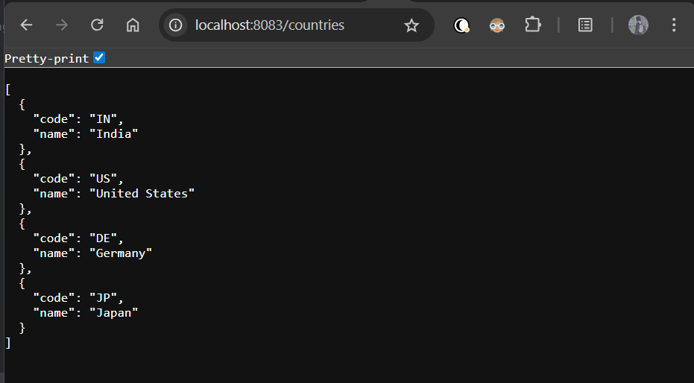

Postman:
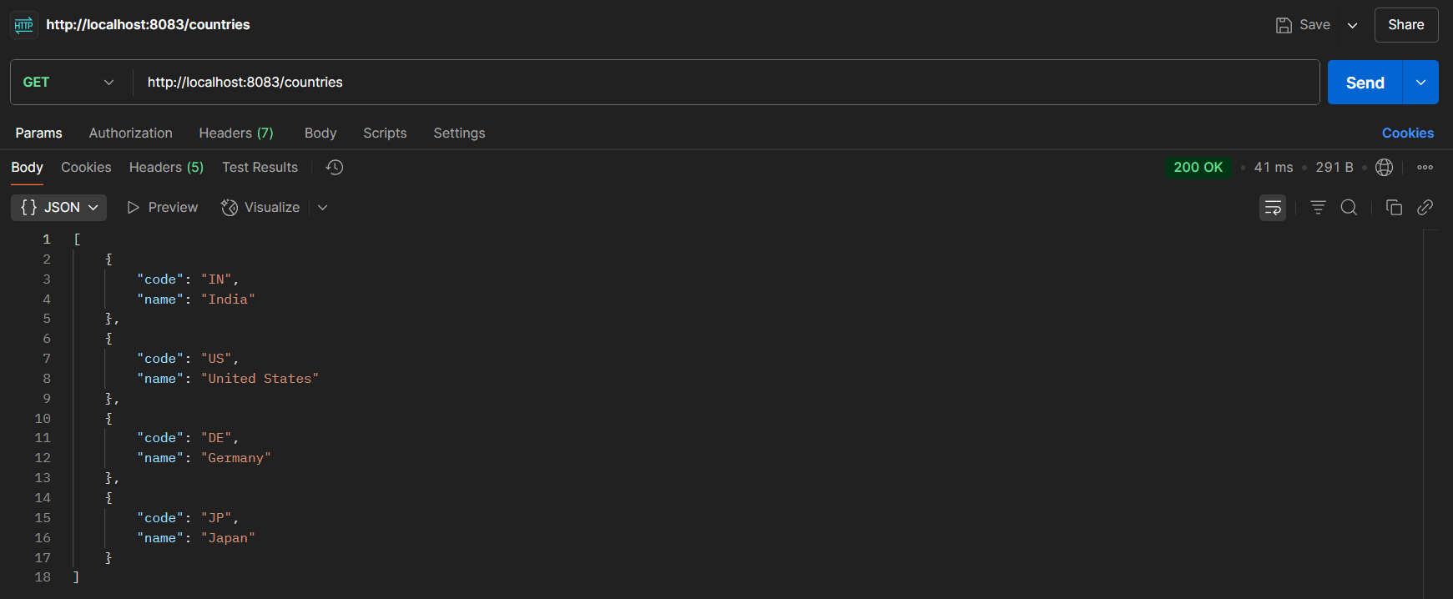

Terminal:
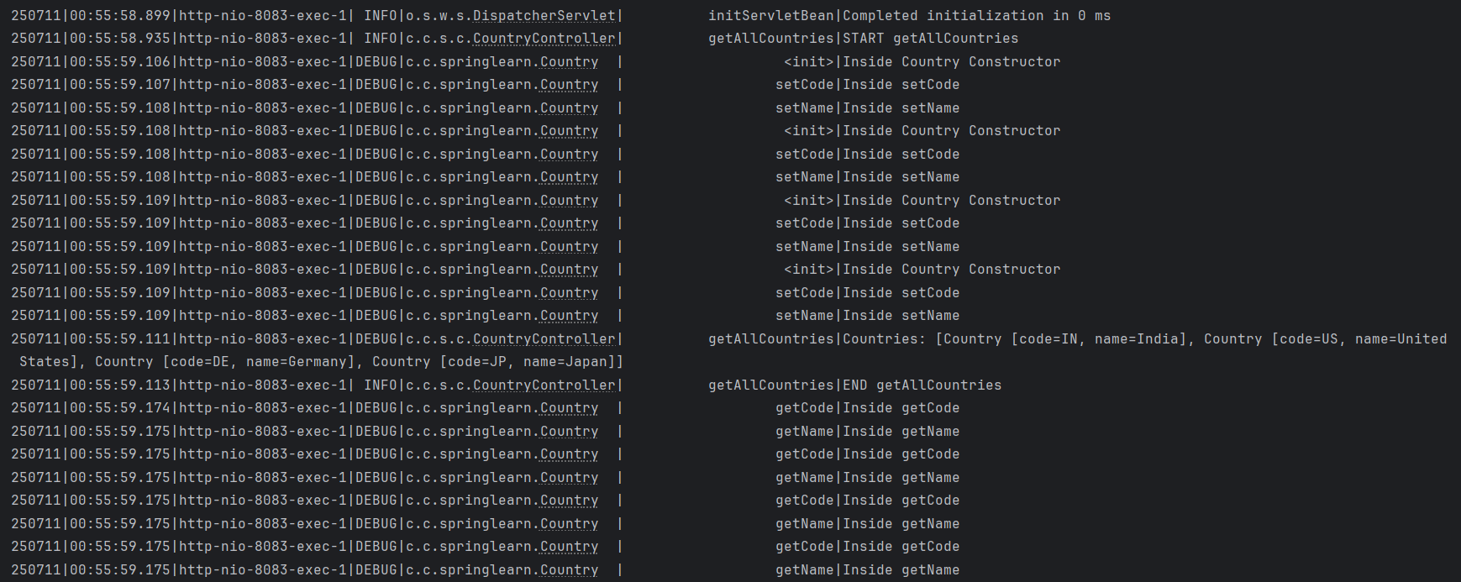

REST - Get country based on country code
CountryService.java

package com.cognizant.springlearn.service;

import com.cognizant.springlearn.Country;
import org.slf4j.Logger;
import org.slf4j.LoggerFactory;
import org.springframework.context.ApplicationContext;
import org.springframework.context.support.ClassPathXmlApplicationContext;
import org.springframework.stereotype.Service;

import java.util.List;

@Service
public class CountryService {
private static final Logger LOGGER = LoggerFactory.getLogger(CountryService.class);

public Country getCountry(String code) {
LOGGER.info("START");
ApplicationContext context = new ClassPathXmlApplicationContext("country.xml");
List<Country> countries = context.getBean("countryList", List.class);

Country result = null;
for (Country country : countries) {
if (country.getCode().equalsIgnoreCase(code)) {
result = country;
break;
}
}

LOGGER.debug("Matched Country: {}", result);
LOGGER.info("END");
return result;
}
}

CountryController.java

package com.cognizant.springlearn.controller;

import com.cognizant.springlearn.Country;
import com.cognizant.springlearn.service.CountryService;
import org.slf4j.Logger;
import org.slf4j.LoggerFactory;
import org.springframework.beans.factory.annotation.Autowired;
import org.springframework.context.ApplicationContext;
import org.springframework.context.support.ClassPathXmlApplicationContext;
import org.springframework.web.bind.annotation.*;

import java.util.List;

@RestController
public class CountryController {

private static final Logger LOGGER = LoggerFactory.getLogger(CountryController.class);

@Autowired
private CountryService countryService;

@RequestMapping("/country")
public Country getCountryIndia() {
LOGGER.info("START getIndia");
ApplicationContext context = new ClassPathXmlApplicationContext("country.xml");
Country country = context.getBean("in", Country.class);
LOGGER.info("END getIndia");
return country;
}

@GetMapping("/countries")
public List<Country> getAllCountries() {
LOGGER.info("START getAllCountries");
ApplicationContext context = new ClassPathXmlApplicationContext("country.xml");
List<Country> countryList = context.getBean("countryList", List.class);
LOGGER.debug("Countries: {}", countryList);
LOGGER.info("END getAllCountries");
return countryList;
}

@GetMapping("/countries/{code}")
public Country getCountry(@PathVariable String code) {
LOGGER.info("START");
Country country = countryService.getCountry(code);
LOGGER.debug("Country found: {}", country);
LOGGER.info("END");
return country;
}
}

Output:

Chrome Browser:
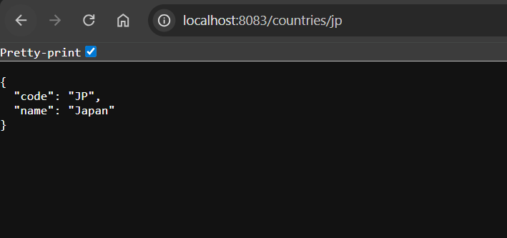

Postman:
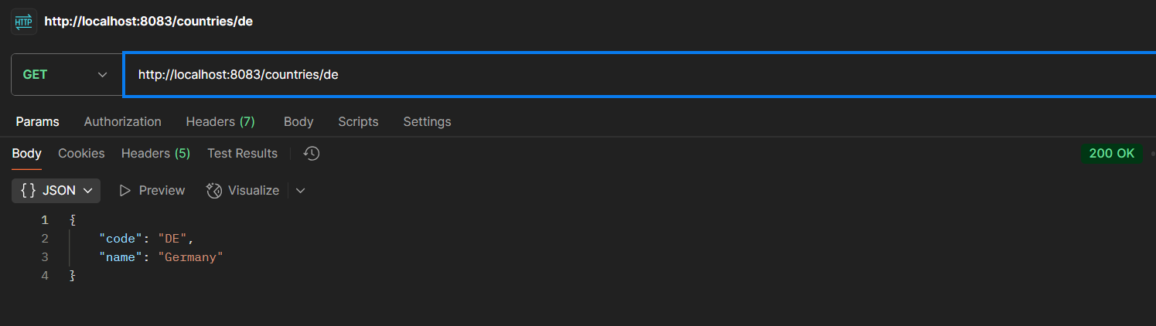

Terminal:
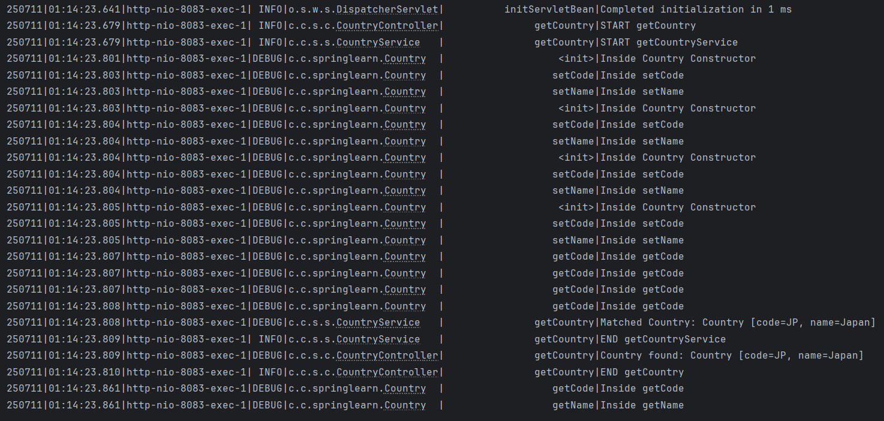

REST - Get country exceptional scenario

CountryNotFoundException.java

package com.cognizant.springlearn.service.exception;

import org.springframework.http.HttpStatus;
import org.springframework.web.bind.annotation.ResponseStatus;

@ResponseStatus(value = HttpStatus.NOT_FOUND, reason = "Country not found")
public class CountryNotFoundException extends Exception {
public CountryNotFoundException() {
super();
}
}

CountryService.java

package com.cognizant.springlearn.service;

import com.cognizant.springlearn.Country;
import com.cognizant.springlearn.service.exception.CountryNotFoundException;
import org.slf4j.Logger;
import org.slf4j.LoggerFactory;
import org.springframework.context.ApplicationContext;
import org.springframework.context.support.ClassPathXmlApplicationContext;
import org.springframework.stereotype.Service;

import java.util.List;

@Service
public class CountryService {
private static final Logger LOGGER = LoggerFactory.getLogger(CountryService.class);

public Country getCountry(String code) throws CountryNotFoundException {
LOGGER.info("START");
ApplicationContext context = new ClassPathXmlApplicationContext("country.xml");
List<Country> countries = context.getBean("countryList", List.class);

for (Country country : countries) {
if (country.getCode().equalsIgnoreCase(code)) {
LOGGER.debug("Matched Country: {}", country);
LOGGER.info("END");
return country;
}
}

LOGGER.error("Country not found: {}", code);
throw new CountryNotFoundException();
}
}

CountryController.java

package com.cognizant.springlearn.controller;

// import statements …
import java.util.List;

@RestController
public class CountryController {

// Existing code…

@GetMapping("/countries/{code}")
public Country getCountry(@PathVariable String code) throws CountryNotFoundException {
LOGGER.info("START");
Country country = countryService.getCountry(code);
LOGGER.debug("Country found: {}", country);
LOGGER.info("END");
return country;
}
}

application.properties:

spring.application.name=spring-learn

logging.level.org.springframework=info
logging.level.com.cognizant.springlearn=debug
logging.pattern.console=%d{yyMMdd}|%d{HH:mm:ss.SSS}|%-20.20thread|%5p|%-25.25logger{25}|%25M|%m%n

server.port=8083

server.error.include-stacktrace=never //to exclude stack trace

Output:

Chrome Browser:

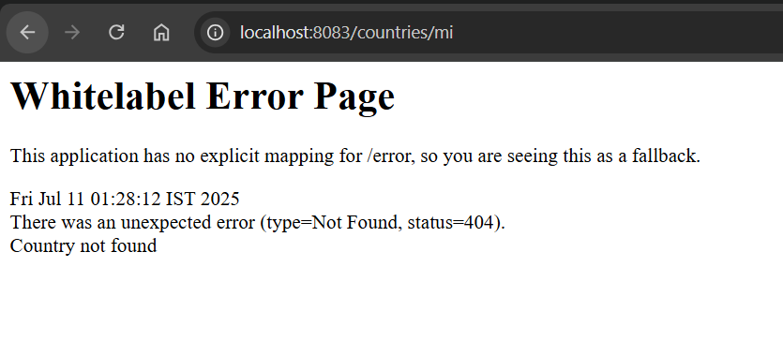

Postman:
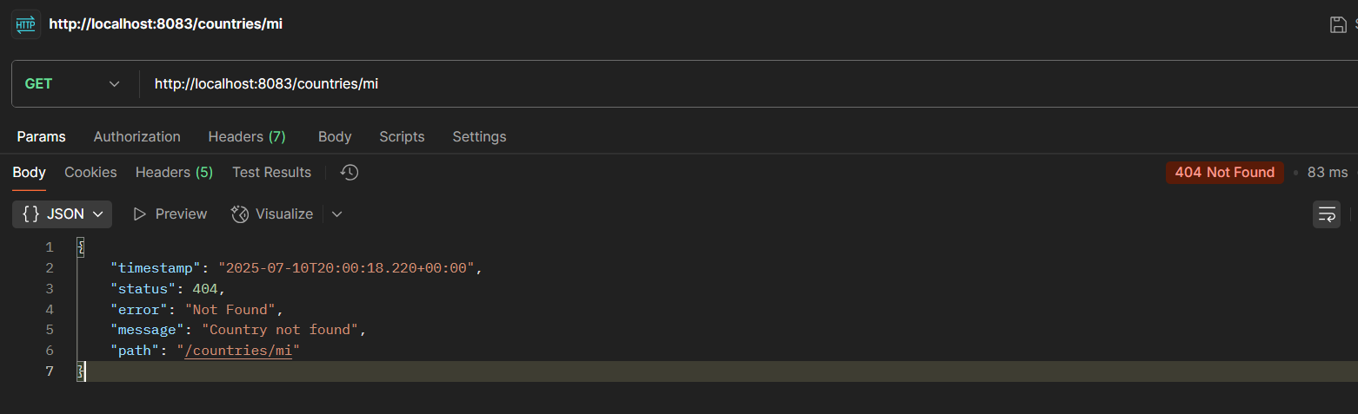

Terminal:
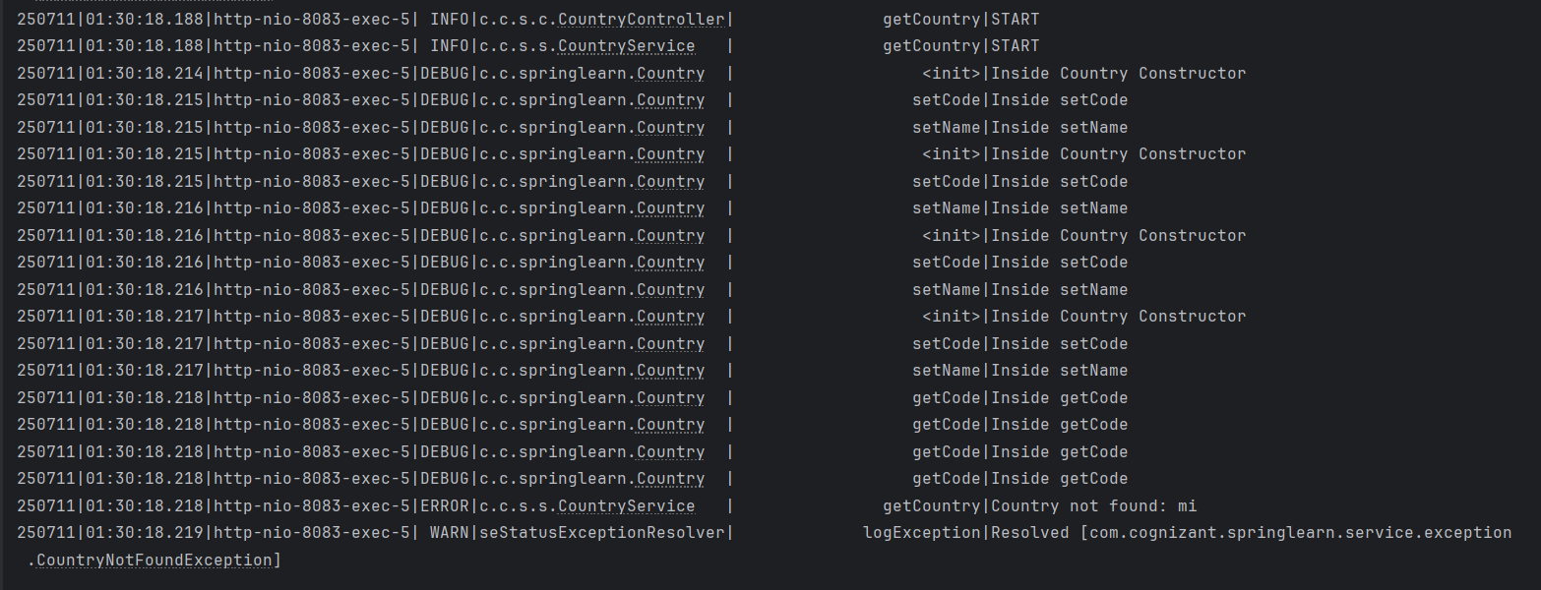

MockMVC - Test get country service

SpringLearnApplicationTest.java

package com.cognizant.springlearn;

import static org.junit.jupiter.api.Assertions.assertNotNull;
import static org.springframework.test.web.servlet.request.MockMvcRequestBuilders.get;
import static org.springframework.test.web.servlet.result.MockMvcResultMatchers.status;
import static org.springframework.test.web.servlet.result.MockMvcResultMatchers.jsonPath;

import com.cognizant.springlearn.controller.CountryController;

import org.junit.jupiter.api.Test;
import org.springframework.beans.factory.annotation.Autowired;
import org.springframework.boot.test.autoconfigure.web.servlet.AutoConfigureMockMvc;
import org.springframework.boot.test.context.SpringBootTest;
import org.springframework.test.web.servlet.MockMvc;
import org.springframework.test.web.servlet.ResultActions;

@SpringBootTest
@AutoConfigureMockMvc
class SpringLearnApplicationTests {

@Autowired
private CountryController countryController;

@Autowired
private MockMvc mvc;

@Test
public void contextLoads() {
assertNotNull(countryController);
}

@Test
public void testGetCountry() throws Exception {
ResultActions actions = mvc.perform(get("/country"));

actions.andExpect(status().isOk())
.andExpect(jsonPath("$.code").exists())
.andExpect(jsonPath("$.code").value("IN"))
.andExpect(jsonPath("$.name").exists())
.andExpect(jsonPath("$.name").value("India"));
}
}

Output:

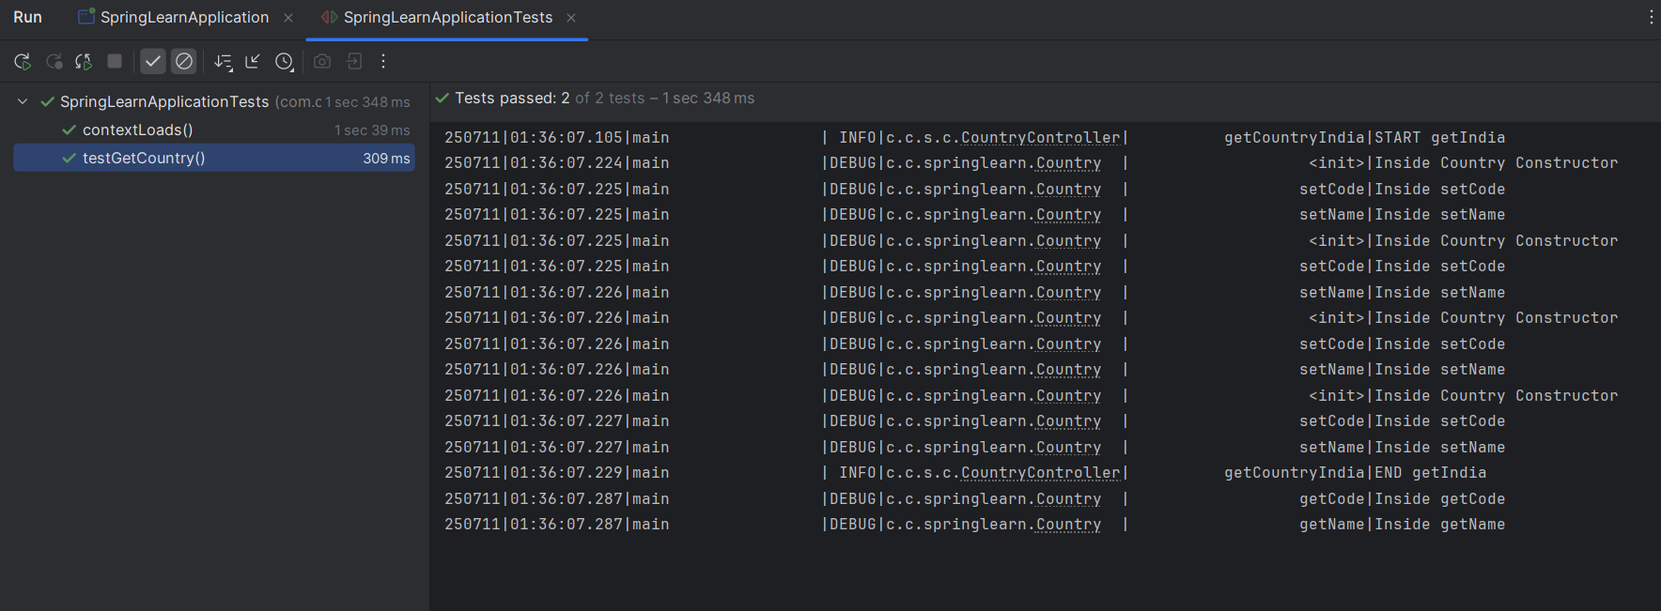

MockMVC - Test get country service for exceptional scenario

SpringLearnApplicationTest.java

package com.cognizant.springlearn;

import static org.junit.jupiter.api.Assertions.assertNotNull;
import static org.springframework.test.web.servlet.request.MockMvcRequestBuilders.get;
import static org.springframework.test.web.servlet.result.MockMvcResultMatchers.status;
import static org.springframework.test.web.servlet.result.MockMvcResultMatchers.jsonPath;

import com.cognizant.springlearn.controller.CountryController;

import org.junit.jupiter.api.Test;
import org.springframework.beans.factory.annotation.Autowired;
import org.springframework.boot.test.autoconfigure.web.servlet.AutoConfigureMockMvc;
import org.springframework.boot.test.context.SpringBootTest;
import org.springframework.test.web.servlet.MockMvc;
import org.springframework.test.web.servlet.ResultActions;

@SpringBootTest
@AutoConfigureMockMvc
class SpringLearnApplicationTests {

@Autowired
private CountryController countryController;

@Autowired
private MockMvc mvc;

@Test
public void contextLoads() {
assertNotNull(countryController);
}

@Test
public void testGetCountry() throws Exception {
ResultActions actions = mvc.perform(get("/country"));

actions.andExpect(status().isOk())
.andExpect(jsonPath("$.code").exists())
.andExpect(jsonPath("$.code").value("IN"))
.andExpect(jsonPath("$.name").exists())
.andExpect(jsonPath("$.name").value("India"));
}

@Test
public void testGetCountryException() throws Exception {
ResultActions actions = mvc.perform(get("/countries/zz"));
actions.andExpect(status().isNotFound())
.andExpect(status().reason("Country not found"));
}
}
Output:

